The Rotary Club of Toowoomba Inc.


The Rotator

Rotary Year 2005-6 Volume 2 – Issue 3. 15th. August 2005.


Guest Speaker
NB.
Our next meeting is Mon. 22nd. August at The Quality Inn.

The meeting is the OFFICIAL VISIT of the DISTRICT GOVERNOR, AILSA HAY, who will bring the district aims and objectives to us.
The meeting is a partner’s night, so bring along the partner of your choice.

Our guest speaker this week was introduced by Chairman Trevor Burstow. Revor told us that Rebecca Nicholas has been teaching for 5 years and is a geography teacher at Fairholme, being there for 3 years.

Rebecca told us that when she started at Fairholme a number of students showed a keen interest in environmental issues and she helped forme a group called Enviro-Angels.

This group has promoted recycling at school, starting with aluminium cans and is now actively encouraging paper recycling, with a paper recycling bin in each classroom.

Aaron Wood the Young Australian of the Year presented at a River Health conference in Toowoomba inspiring the girls to take an active interest in the topic of Water Management.

This resulted in the girls attending the NSW conference in Narrabri and now will take part in a second in Mildura in 2005.

Rebecca told us that the Girls not only spoke at the Narrabri Conference but prepared and ran ‘hands-on’ workshops on recycling issues and water management.

The focus of the girls is now mainly Water Management and they are actively raising funds to cover expenses for the ‘Enviro-Angel’s trip to Mildura.

Rebecca delivered a powerpoint presentation with passion and commitment, and indicated to the membership that the girls also are involved locally in the ‘Clean-Up Australia’ campaign.

The presentation was well received by the members and our own Ray Taylor proposed the vote of thanks on behalf of the Club.

Pres. Perry, in his closing address indicated that as it was probably our generation that caused many of the problems associated with the current situation he was pleased that the younger generation is actively looking for solutions.

For more information on River Health go to
http://www.riverhealth.com/mildura.php

Our Website is active on www.rotarytoowoomba.org.au :

Rebecca was presented with a certificate of
appreciation indicating that a donation would be made in her name to the A.R.H.R.F.
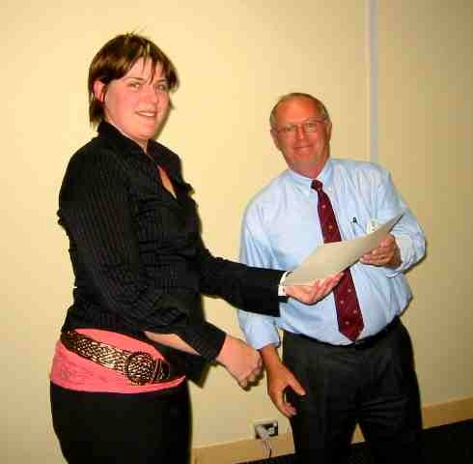

Inside this issue :

Presidents News | 2
International Service | 2
Late News | 2
APOLOGIES & Duty Roster | 2
SergeantS Corner | 3

Inside this issue:

Inside this issue:

Inside this issue:

Inside this issue:

PAge 1.

The Rotator – 2005-6 Vol.2 Iss 3. 15th. August 2005

President Perry’s News
President Perry welcomed our Guest Speaker – Rebecca Nicholas along with club guests, the Mitsukaido Kids, Tomo, Makoto, Takayoshi and Ryota.

Pres. Perry reminded the club of the upcoming Ag Show and said that he would prefer that all Rotarians attending the Burger Hut wear the Club Tee – Shirt. These were still available from Jeff Collard at a cost of $ 35.00.
A special thanks was made to the host families and those others involved with the Mitsukaido visitors, and a special thanks to Ray Inglis who escorted the kids to the Gold Coast.

Pres. Perry provided an up-date on Kerrie Klan’s condition, surgery was completed successfully and the Club asked Linda Evans to pass on our best wishes to Stan and Kerrie.

Community Service - Committee News
Steve Hazzard advised and circulated the roster for the up-coming Ag Show. Any-one wishing to change should make the arrangements and advise the appointed Shift Captains as indicated in red
on the attached Roster.
Steve also advised that Rotary Christmas Puddings were available and members should contact him with any requirements.

International Service - Committee News

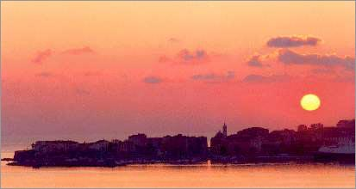
Mary-Ann Wheatley proposed the International toast in the absence of Rob McCormack. The 15th of August 1769 was the birth date of Napoleon Bonaparte. Our International Toast was to the Rotary Club of Ajaccio in District 1730.
(for those guessing why, Ajaccio, it is the capital of Corsica.)

LATE NEWS :
Secretaries Announcements :

Acting secretary Jeff Collard advised that
there were 7 non-apologies this week. Jeff sought support from non-attending members to apologise, to allow us to keep costs to a minimum.
Next week’s Roster :
Guest Speaker : DG Ailsa Hay
Chair : Errol Wildman
Dinner Duty : Ray French
Reception : JuriJ Petrewski
Charity Box : David Snow
Vote of Thanks : Nev Easton
Raffle : Steve Brown

The Rotators this month are brought to you by :

Computing Solutions,
a division of
Galanta Productions P/L
. 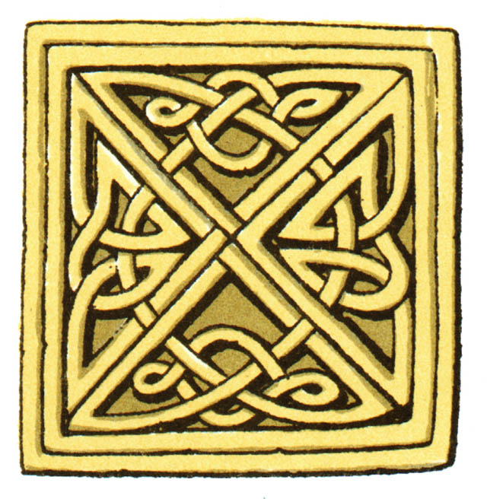
Specialist I.T.
in Event Management.

Email :
computingsolutions @ bigpond.com.

You too can buy this space.
Pres. Perry showed the Club the gift received from the R.C. of Mitsukaido. A set of ceremonial Chopsticks and Fan.

Pres. Perry also advised the contents of the letter of thanks sent to us by Pres. Kiyoto Aoki. Pres. Aoki expressed his gratitude for our continued support (19 years) of the exchange programme extolling the benefits to the children.

Attendance last month was 68.35%
(courtesy Bernie Leahy)

Apologies 11
Make Ups: TBA

Page 2.

The Rotator – 2005-6 Vol.2 Iss 3. 15th. August 2005

Places to make up:

The Rotary Club of Toowoomba Inc.
SERVICE ABOVE SELF
Meets at the Quality Inn
Ruthven Street
Toowoomba Qld.
Monday at 5.30 for 6.00 p.m.
Phone: 07 46 32 2433 to book in or out

Attendance Requirements
Each member must attend or make up at least sixty percent of club regular meetings in each half of the Rotary year.

Guest Book-In & Apologies
Direct to the Quality Inn Burke & Wills. Phone 4632 2433 by 12.00 noon on the day of the meeting. This is required for catering purposes.

Making Up
Making up is valid for 14 days before or after the usual time for that meeting. There is no time restriction for making up during overseas travel. Participation in authorised Club projects and events can also be counted as make ups.

Postal Address: P.O. Box 113
Toowoomba Qld 4350
or Email: toowoomba@rotary9630.org

We’re on the web at www.rotarytoowoomba.org.au

Sergeant’s Corner
Ponderings

Baton Carriers, Nigel Beaman and Doug Collyer were appointed and required to pay for the ‘privilege’.

Lorraine was fined in recognition of the anniversary of her induction date, similarly Ray Poulton was fined for his wedding anniversary. Bill Armagnacq for his recent misdemeanours at a school reunion in Cairns, involving a hair piece ?
Martin was fined for getting the count wrong at dinner and for short paying, Mark Liebke for not wolf-whistling anymore ? and winning the golf comp. Jeff Collard for his red and white bias (St Helens ?) along with Andrew Tilley his part in the Getaway and Marcus for being involved in ‘hugging trees’ ?

The sergeant provided a humorous list of QANTAS anecdotes regarding dialogue between flight and ground crews, known as the ‘Gripe Sheet’, including the Editor’s favourites ………

Flight Crew : Selecting ‘Auto-Land’ feature results in rough landing.
Ground Crew : Auto-Land feature not installed ???????
and
Flight Crew : Left offside tyre almost needs replacement.
Ground Crew : Left offside tyre almost replaced.
Sergeant Tim ponderered ;

Why doesn’t glue stick in the bottle ?

If any one can help please contact Tim Davis …..

Editorial Note : The Rotator this week is accompanied by The Ag. Show Roster.

Please contact Steve Hazzard for further information

Page 3.

The Rotator – 2005-6 Vol.2 Iss 3. 15th. August 2005

Special Supplement. - VISIT BY THE MISUKAIDO Children.

This Friendship project is in its 19th year.

the Rotary Club of Mitsukaido, Ibaraki in District 2820 in Japan send a group of children to Australia and in exchange the Rotary Club of Toowoomba send their children to Mitsikaido.
The group led by Tomo presented
a gift from the R.C. of Mitsukaido
to president Perry.
In return President perry presented each boy with a boomerang and banner for their Bedroom walls as a reminder of their time in Toowoomba.
Pres.ident Perry also sent similar gift to President Aoki of the Rotary Club of Mitsukaido Ibaraki .
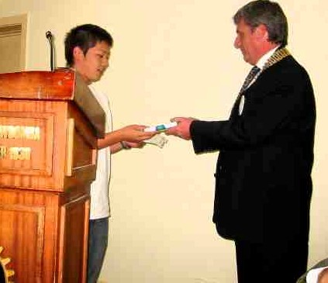

This special night each of the kids spoke in turn about their experiences……

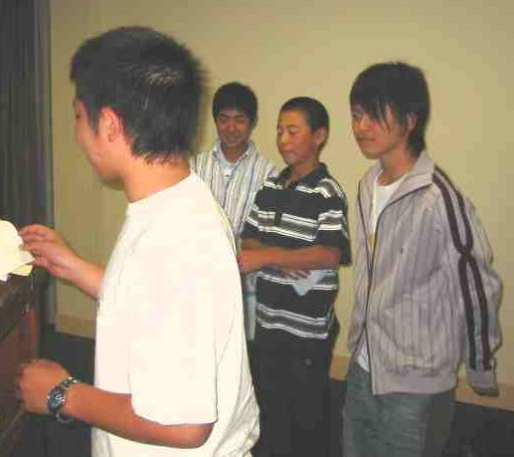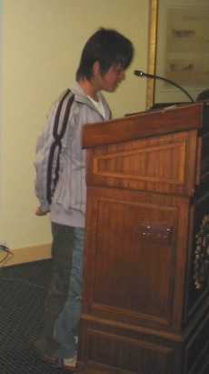

Firstly Tomo spoke of our clear skies Followed by Makoto who thanked
and how much he enjoyed them for its hospitality.

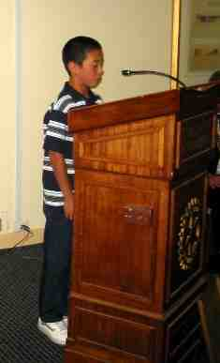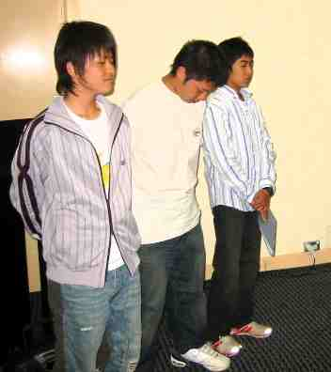
Ryoda told us that there The others looked on lastly
were 5 in his family and of Takayoshi told us that he liked to
his happiness at buying them play rugby and play loud music.
souveniers

